**Module-9: Kubernetes Assignment - 3**

You have been asked to:

● Use the previous deployment

● Change the replicas to 5 for the deployment

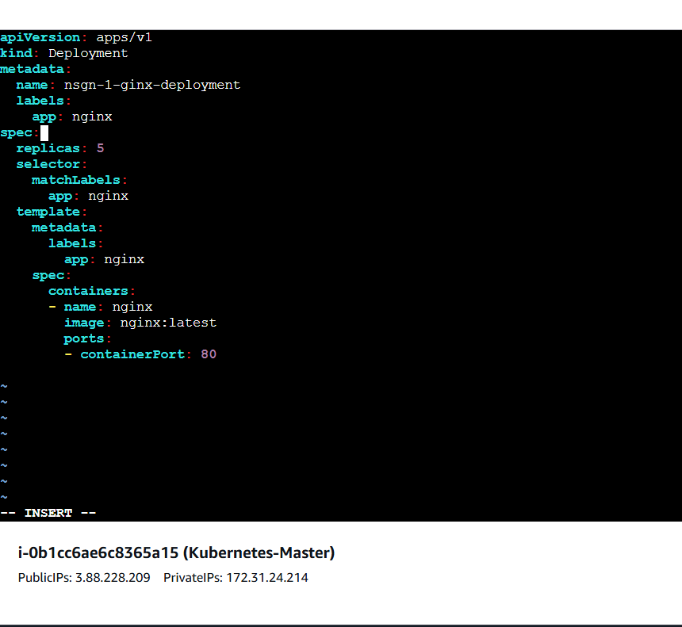

To see the deployment

